Parallelogram-Base Prism
# Source: AI Source: Provided by: [Data Path: Persons Table -> ID Column: 1, Name_En Column: Motasem Essam] -> From: [ChatGPT] on [7/25/2026]
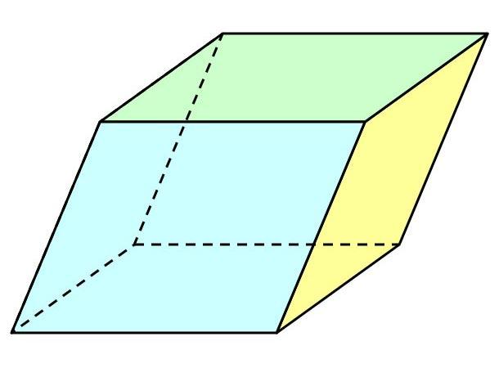
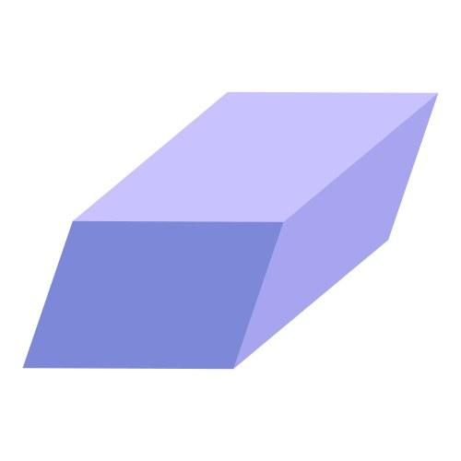
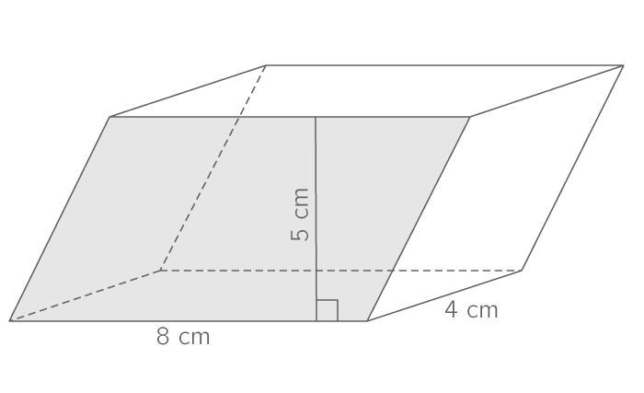

Definition
# Source: AI Source: Provided by: [Data Path: Persons Table -> ID Column: 1, Name_En Column: Motasem Essam] -> From: [ChatGPT] on [7/25/2026]
A parallelogram-base prism is a three-dimensional polyhedron with two congruent, parallel parallelograms as its bases, connected by four lateral faces.
A parallelogram is a quadrilateral in which both pairs of opposite sides are parallel. Its opposite sides and opposite angles are equal, and its diagonals bisect one another.
A parallelogram-base prism has:
- 2 parallelogram-shaped bases.
- 4 lateral faces.
- 6 faces in total.
- 12 edges.
- 8 vertices.
The lateral faces are rectangles in a right prism and parallelograms in an oblique prism.

Simple Definition
# Source: AI Source: Provided by: [Data Path: Persons Table -> ID Column: 1, Name_En Column: Motasem Essam] -> From: [ChatGPT] on [7/25/2026]
A parallelogram-base prism is a 3D solid formed by extending a parallelogram in a direction to create depth, producing a matching parallelogram at the other end.

Classification Tree
# Source: AI Source: Provided by: [Data Path: Persons Table -> ID Column: 1, Name_En Column: Motasem Essam] -> From: [ChatGPT] on [7/25/2026]
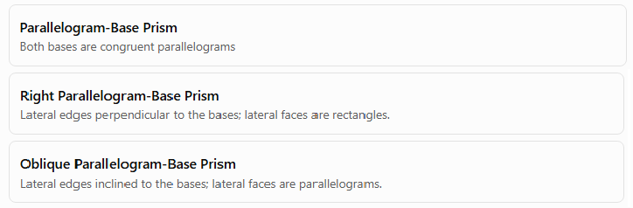
Parallelogram-Base Prism
Both bases are congruent parallelograms
Right Parallelogram-Base Prism
Lateral edges perpendicular to the bases; lateral faces are rectangles.
Oblique Parallelogram-Base Prism
Lateral edges inclined to the bases; lateral faces are parallelograms.
This classification describes the base shape and the orientation of the lateral edges. A parallelogram-base prism may also have a more specific base classification, such as a rectangle, rhombus, or square.

Key Characteristics
# Source: AI Source: Provided by: [Data Path: Persons Table -> ID Column: 1, Name_En Column: Motasem Essam] -> From: [ChatGPT] on [7/25/2026]
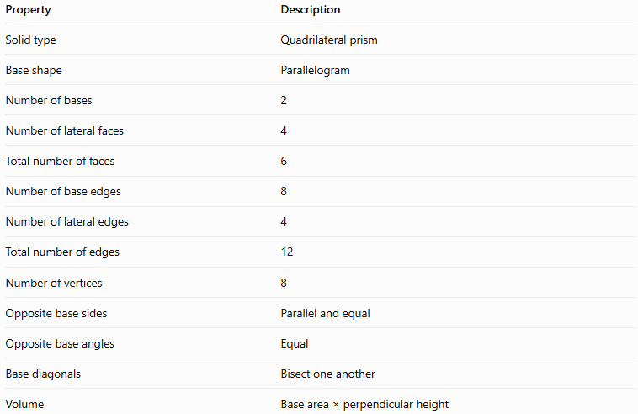
Property | Description
Solid type | Quadrilateral prism
Base shape | Parallelogram
Number of bases | 2
Number of lateral faces | 4
Total number of faces | 6
Number of base edges | 8
Number of lateral edges | 4
Total number of edges | 12
Number of vertices | 8
Opposite base sides | Parallel and equal
Opposite base angles | Equal
Base diagonals | Bisect one another
Volume | Base area × perpendicular height

Geometric Representation
# Source: AI Source: Provided by: [Data Path: Persons Table -> ID Column: 1, Name_En Column: Motasem Essam] -> From: [ChatGPT] on [7/25/2026]
The main components are:
- Base faces: Two congruent, parallel parallelograms.
- Lateral faces: Four faces connecting corresponding sides of the bases.
- Base edges: Eight edges in total, four on each base.
- Lateral edges: Four edges joining corresponding base vertices.
- Vertices: Eight corner points.
- Height: The perpendicular distance between the two base planes, which may differ from the length of a lateral edge in an oblique prism.

Mathematical Representations and Formulas
# Source: AI Source: Provided by: [Data Path: Persons Table -> ID Column: 1, Name_En Column: Motasem Essam] -> From: [ChatGPT] on [7/25/2026]
Let:
- $a,b$ = lengths of the two adjacent sides of the parallelogram.
- $θ$ = angle between those sides.
- $B$ = area of one base.
- $p$ = perimeter of the base.
- $h$ = perpendicular height of the prism.
- $A_{L}$ = lateral surface area.
- $A_{T}$ = total surface area.
- $V$ = volume.

A. Base area
# Source: AI Source: Provided by: [Data Path: Persons Table -> ID Column: 1, Name_En Column: Motasem Essam] -> From: [ChatGPT] on [7/25/2026]
The area of a parallelogram is the product of its adjacent side lengths and the sine of their included angle:
$$\boxed{B=ab\sin{θ}}$$
Alternatively, if $b$ is the base length and $k$ is the perpendicular altitude of the parallelogram:
$$B=bk$$

B. Base perimeter
# Source: AI Source: Provided by: [Data Path: Persons Table -> ID Column: 1, Name_En Column: Motasem Essam] -> From: [ChatGPT] on [7/25/2026]
Opposite sides of a parallelogram are equal. Therefore:
$$\boxed{p=2\left(a+b\right)}$$

C. Volume
# Source: AI Source: Provided by: [Data Path: Persons Table -> ID Column: 1, Name_En Column: Motasem Essam] -> From: [ChatGPT] on [7/25/2026]
The volume of a prism equals its base area multiplied by its perpendicular height:
$$\boxed{V=Bh}$$
For a parallelogram-base prism:
$$\boxed{V=abh\sin{θ}}$$
This formula applies to both right and oblique prisms.

D. Lateral surface area
# Source: AI Source: Provided by: [Data Path: Persons Table -> ID Column: 1, Name_En Column: Motasem Essam] -> From: [ChatGPT] on [7/25/2026]
For a right parallelogram-base prism, the lateral faces are rectangles. The lateral surface area is:
$$A_{L}=ph$$
Substituting the base perimeter:
$$\boxed{A_{L}=2\left(a+b\right)h}$$
For an oblique parallelogram-base prism, the lateral surface area is the sum of the areas of its four lateral parallelograms. It cannot generally be calculated as $ph$ using the perpendicular height between the bases.

E. Total surface area
# Source: AI Source: Provided by: [Data Path: Persons Table -> ID Column: 1, Name_En Column: Motasem Essam] -> From: [ChatGPT] on [7/25/2026]
The total surface area is the lateral surface area plus the areas of both bases:
$$A_{T}=A_{L}+2B$$
For a right parallelogram-base prism:
$$\boxed{A_{T}=2\left(a+b\right)h+2ab\sin{θ}}$$

Worked Examples
# Source: AI Source: Provided by: [Data Path: Persons Table -> ID Column: 1, Name_En Column: Motasem Essam] -> From: [ChatGPT] on [7/25/2026]
Example 1: Counting faces, edges, and vertices
Problem: Find the number of faces, edges, and vertices of a parallelogram-base prism.
Since a parallelogram is a quadrilateral, $n=4$.
For an $n$-gonal prism:
$$F=n+2, E=3n, V=2n$$
Therefore:
- Faces: $F=4+2=6$
- Edges: $E=3\left(4\right)=12$
- Vertices: $V=2\left(4\right)=8$
Answer: 6 faces, 12 edges, and 8 vertices.
Example 2: Calculating the base area
Problem: A parallelogram has adjacent sides of $8\text{ cm}$ and $5\text{ cm}$, with an included angle of ${30}^{∘}$. Find its area.
Using the formula:
$$B=ab\sin{θ}$$
Substitute the values:
$$B=8\left(5\right){\sin{30}}^{∘}$$
Since ${\sin{30}}^{∘}=\frac{12}{}$:
$$B=40\left(\frac{12}{\backslash right})\right.$$
$$\boxed{B=20{\text{ cm}}^{2}}$$
Example 3: Calculating the volume
Problem: A parallelogram-base prism has a base area of $35{\text{ cm}}^{2}$ and a perpendicular height of $12\text{ cm}$. Find its volume.
Using:
$$V=Bh$$
$$V=35\left(12\right)$$
$$\boxed{V=420{\text{ cm}}^{3}}$$
Example 4: Calculating lateral and total surface areas
Problem: A right parallelogram-base prism has adjacent base sides of $6\text{ cm}$ and $4\text{ cm}$, an included angle of ${60}^{∘}$, and a height of $10\text{ cm}$. Find its lateral and total surface areas.
Step 1: Calculate the base area.
$$B=ab\sin{θ}$$
$$B=6\left(4\right){\sin{60}}^{∘}$$
Because ${\sin{60}}^{∘}=\frac{\sqrt{3}}{2}$:
$$B=12\sqrt{3}{\text{ cm}}^{2}$$
Step 2: Calculate the lateral surface area.
$$A_{L}=2\left(a+b\right)h$$
$$A_{L}=2\left(6+4\right)\left(10\right)$$
$$\boxed{A_{L}=200{\text{ cm}}^{2}}$$
Step 3: Calculate the total surface area.
$$A_{T}=A_{L}+2B$$
$$A_{T}=200+24\sqrt{3}$$
$$\boxed{A_{T}≈241.57{\text{ cm}}^{2}}$$
Example 5: Verifying Euler’s formula
Euler’s formula for a convex polyhedron is:
$$V-E+F=2$$
For this prism, $V=8$, $E=12$, and $F=6$.
$$8-12+6=2$$
Therefore, Euler’s formula is satisfied.

Comparison with Other Quadrilateral Prisms
# Source: AI Source: Provided by: [Data Path: Persons Table -> ID Column: 1, Name_En Column: Motasem Essam] -> From: [ChatGPT] on [7/25/2026]
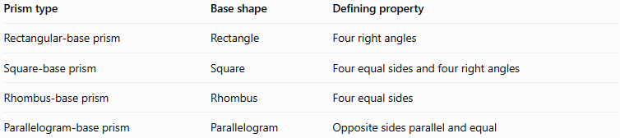
Prism type | Base shape | Defining property
Rectangular-base prism | Rectangle | Four right angles
Square-base prism | Square | Four equal sides and four right angles
Rhombus-base prism | Rhombus | Four equal sides
Parallelogram-base prism | Parallelogram | Opposite sides parallel and equal
These categories overlap because rectangles, rhombuses, and squares are all special types of parallelograms.
- Every square-base prism is a parallelogram-base prism.
- Every rectangular-base prism is a parallelogram-base prism.
- Every rhombus-base prism is a parallelogram-base prism.
- Not every parallelogram-base prism has a rectangular, square, or rhombus base.

Constructing Parallelogram-Base Prism in Solid Geometry

Instruments Used
# Source: AI Source: Provided by: [Data Path: Persons Table -> ID Column: 1, Name_En Column: Motasem Essam] -> From: [ChatGPT] on [7/25/2026]
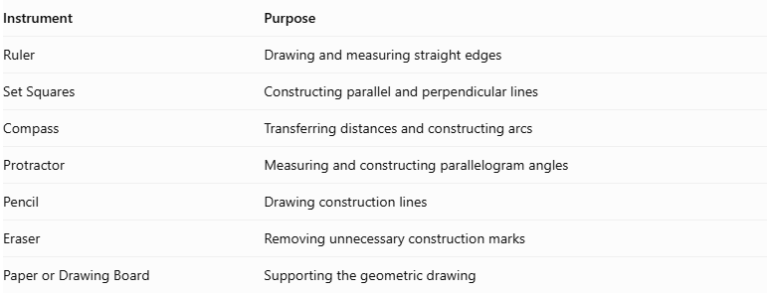
Instrument | Purpose
Ruler | Drawing and measuring straight edges
Set Squares | Constructing parallel and perpendicular lines
Compass | Transferring distances and constructing arcs
Protractor | Measuring and constructing parallelogram angles
Pencil | Drawing construction lines
Eraser | Removing unnecessary construction marks
Paper or Drawing Board | Supporting the geometric drawing

Construction Procedures

Isometric Construction
# Source: AI Source: Provided by: [Data Path: Persons Table -> ID Column: 1, Name_En Column: Motasem Essam] -> From: [ChatGPT] on [7/25/2026]
- Determine the lengths of the two pairs of opposite sides of the parallelogram base.
- Determine one interior angle of the parallelogram.
- Determine the required prism height.
- Draw the first parallelogram-shaped base using a ruler and protractor.
- Represent the base in the selected isometric drawing orientation.
- From each base vertex, draw a lateral edge representing the prism height.
- Ensure that all lateral edges are equal and parallel.
- Draw the second congruent parallelogram at the opposite ends of the lateral edges.
- Connect the corresponding vertices to complete the four lateral faces.
- Distinguish visible and hidden edges and label the dimensions.
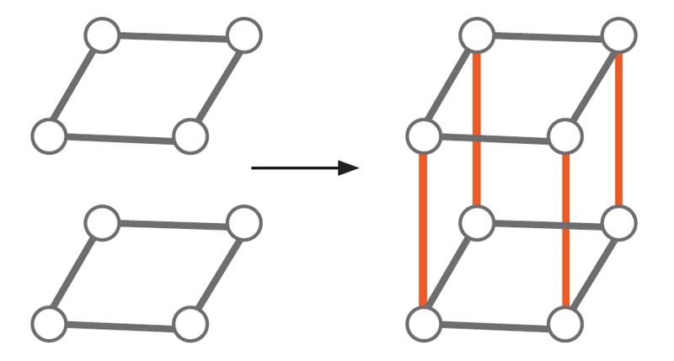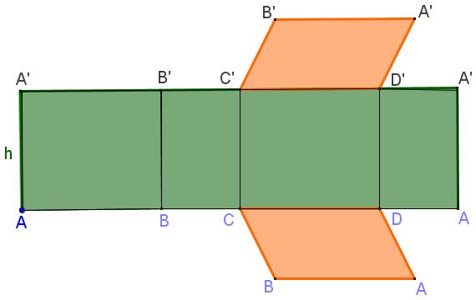

Orthographic Construction
# Source: AI Source: Provided by: [Data Path: Persons Table -> ID Column: 1, Name_En Column: Motasem Essam] -> From: [ChatGPT] on [7/25/2026]
- Determine the parallelogram side lengths, interior angles, and prism height.
- Draw the top view as a parallelogram.
- Draw the front view according to the selected viewing direction.
- Draw the side view showing the corresponding base dimension and prism height.
- Align the three views according to the selected orthographic projection convention.
- Ensure that corresponding dimensions are consistent.
- Add visible and hidden lines where necessary.
- Label the base dimensions and height.

Face-Based Construction
# Source: AI Source: Provided by: [Data Path: Persons Table -> ID Column: 1, Name_En Column: Motasem Essam] -> From: [ChatGPT] on [7/25/2026]
- Draw the first parallelogram-shaped base.
- Determine the required prism height.
- Draw a second congruent parallelogram at the required distance.
- Keep both bases parallel.
- Connect the corresponding vertices of the two parallelograms.
- Complete the four lateral faces.
- For a right prism, ensure that the connecting edges are perpendicular to the base planes.
- Refine the edges and visible surfaces.

Edge-Based Construction
# Source: AI Source: Provided by: [Data Path: Persons Table -> ID Column: 1, Name_En Column: Motasem Essam] -> From: [ChatGPT] on [7/25/2026]
- Select a starting vertex.
- Draw one side of the parallelogram base.
- Construct the adjacent side using its required length and interior angle.
- Complete the parallelogram by drawing opposite sides parallel to each other.
- Draw the four lateral edges from the base vertices.
- Ensure that the lateral edges are equal and parallel.
- For a right prism, construct the lateral edges perpendicular to the base plane.
- Connect the upper endpoints to form the second parallelogram.
- Complete the lateral faces and refine the solid.

Net-Based Construction
# Source: AI Source: Provided by: [Data Path: Persons Table -> ID Column: 1, Name_En Column: Motasem Essam] -> From: [ChatGPT] on [7/25/2026]
- Determine the lengths of the four sides of the parallelogram base.
- Draw four rectangles representing the lateral faces of a right parallelogram-base prism.
- Arrange the four rectangles in a connected strip.
- Attach two congruent parallelograms to suitable edges of the strip.
- Ensure that the rectangular faces have widths corresponding to the four base side lengths.
- Set the other dimension of each rectangle equal to the prism height.
- Add tabs if needed for physical assembly.
- Cut out the net.
- Fold along the edges and join the matching boundaries to form the prism.
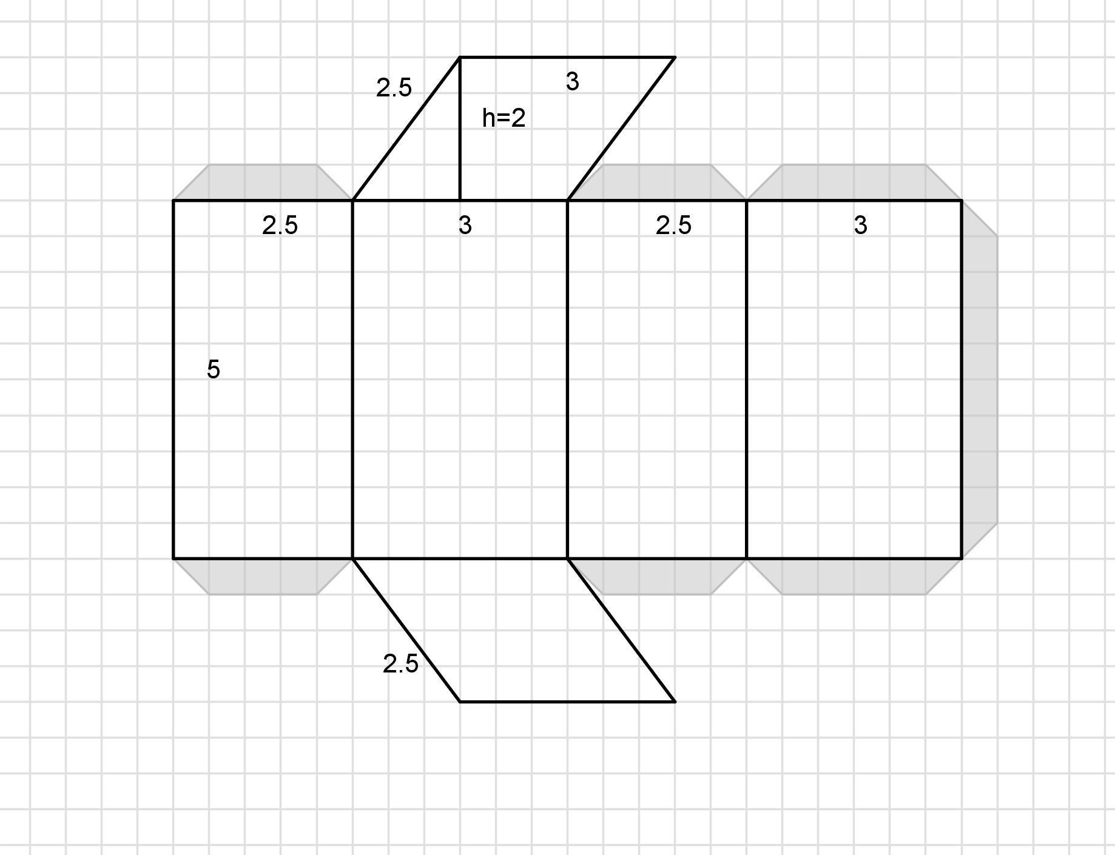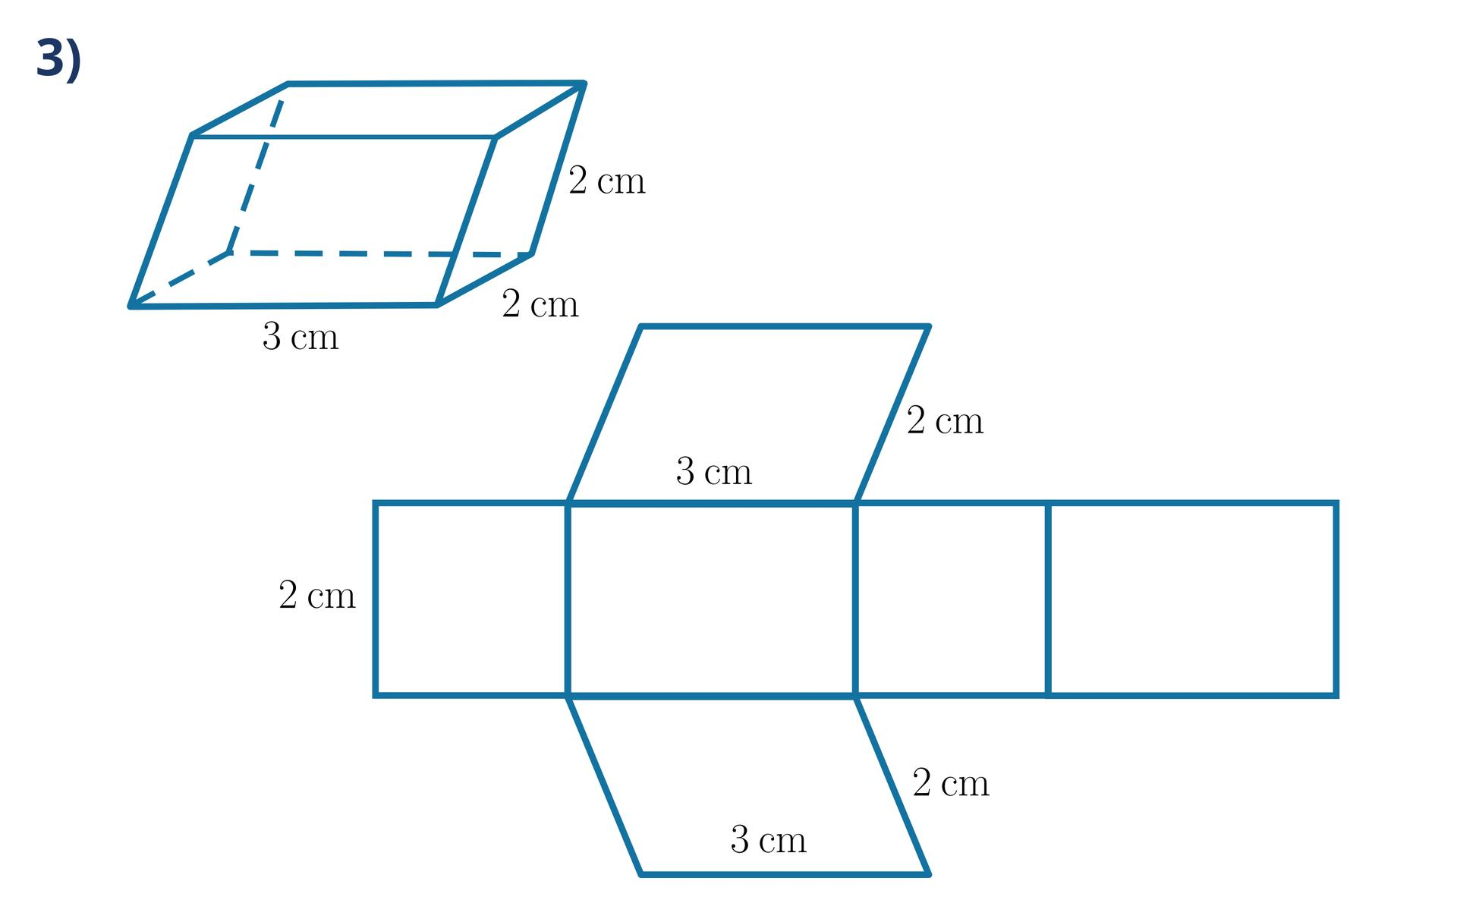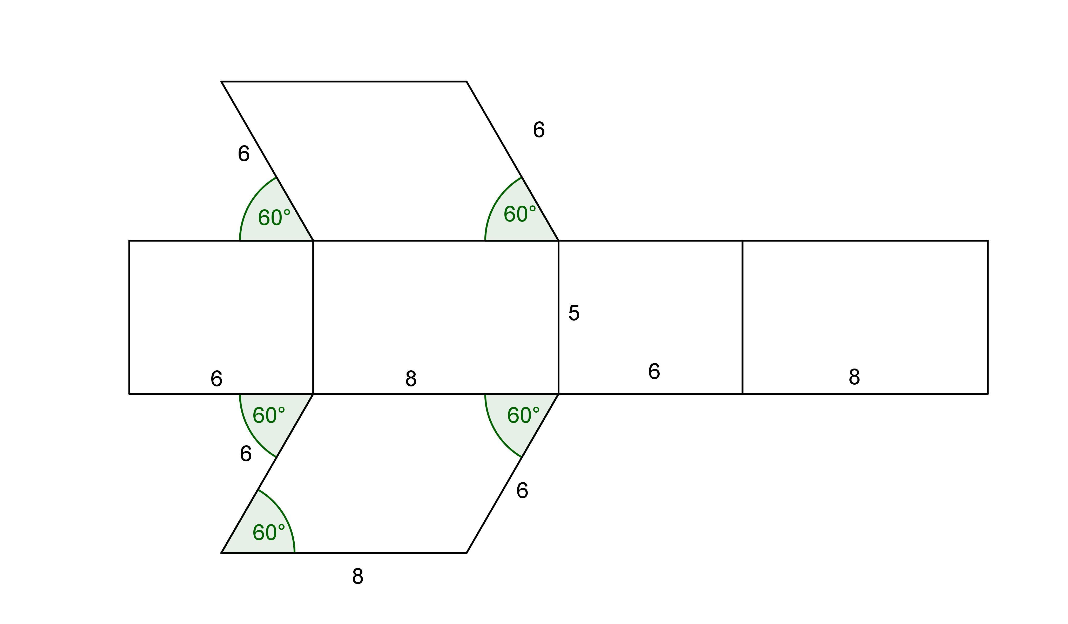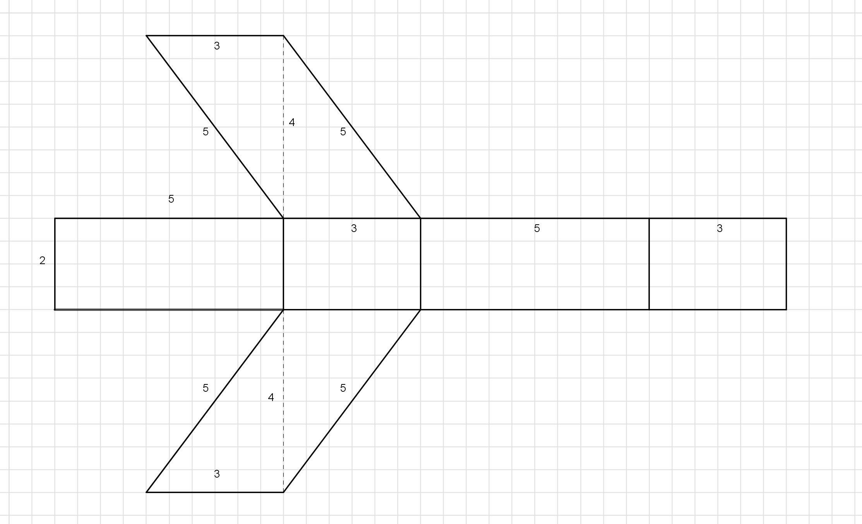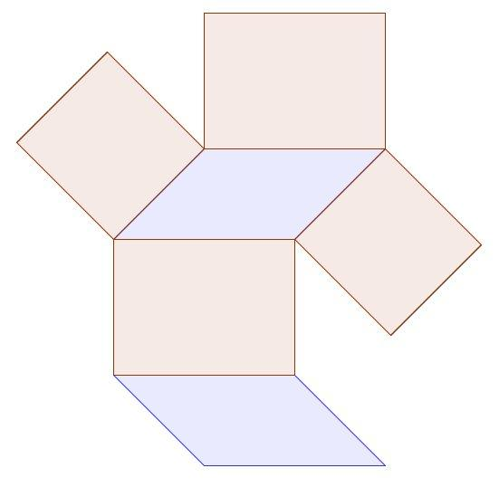

Applications
# Source: AI Source: Provided by: [Data Path: Persons Table -> ID Column: 1, Name_En Column: Motasem Essam] -> From: [ChatGPT] on [7/25/2026]
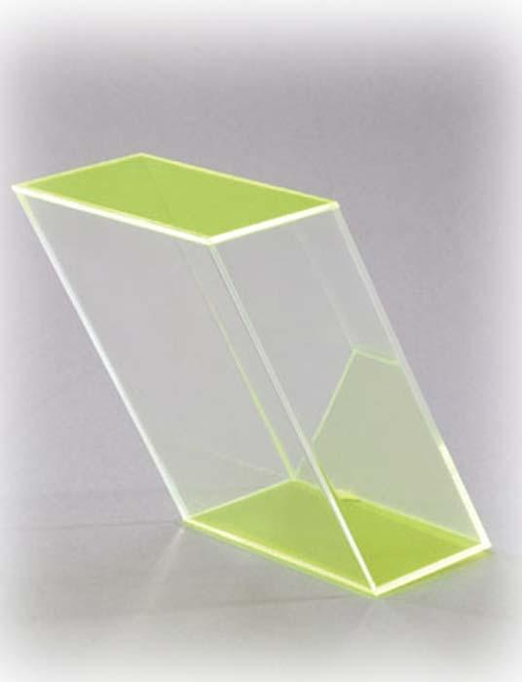
Architecture and design
Parallelogram prisms can model slanted structural forms, decorative solids, and geometric building components.
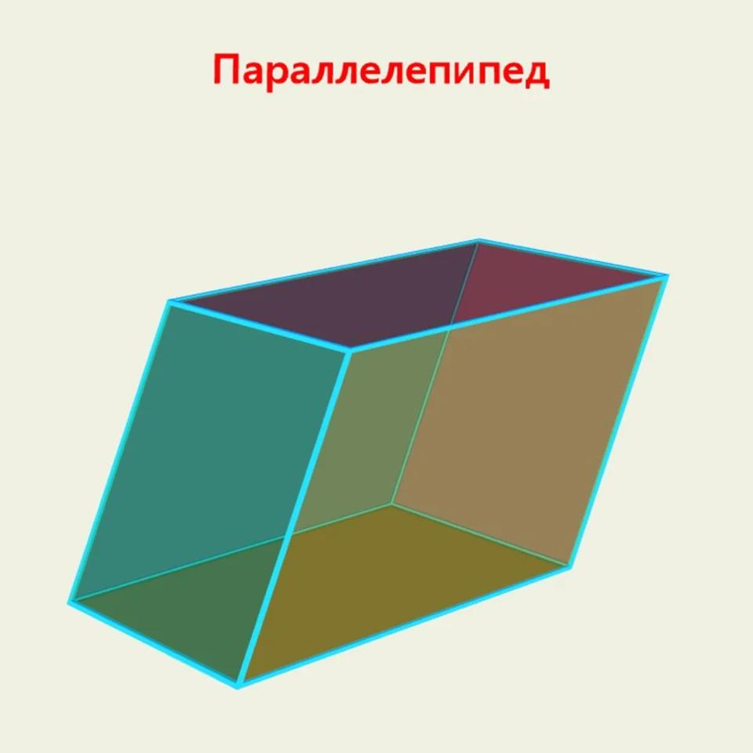
Mathematics education
They help explain parallel planes, quadrilateral properties, volume, surface area, and three-dimensional geometry.
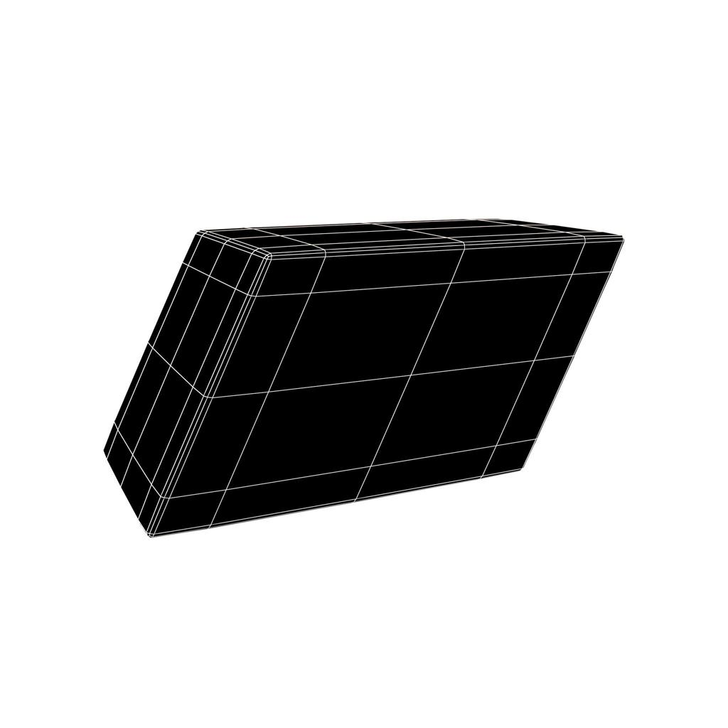
Engineering and 3D modeling
Their geometry is useful for modeling skewed solids, spatial transformations, and structures with parallel faces.

Key Points
# Source: AI Source: Provided by: [Data Path: Persons Table -> ID Column: 1, Name_En Column: Motasem Essam] -> From: [ChatGPT] on [7/25/2026]
- A parallelogram-base prism has two congruent, parallel parallelogram bases.
- It has 6 faces, 12 edges, and 8 vertices.
- The opposite sides of each base are parallel and equal.
- The diagonals of each base bisect one another.
- Its volume is $V=Bh$.
- For a right prism, its lateral surface area is $A_{L}=ph=2\left(a+b\right)h$.
- A rectangular prism, rhombus-base prism, and square-base prism are all special cases within the broader parallelogram-base category.
- For an oblique prism, calculate lateral surface area from the individual lateral faces rather than automatically using $ph$.

Conclusion
# Source: AI Source: Provided by: [Data Path: Persons Table -> ID Column: 1, Name_En Column: Motasem Essam] -> From: [ChatGPT] on [7/25/2026]
A parallelogram-base prism is a quadrilateral prism whose bases are parallelograms. Its defining properties come from the parallel and equal opposite sides of the base, together with the standard structure of a prism. It has six faces, twelve edges, and eight vertices, and its volume is found by multiplying the base area by the perpendicular height. Understanding this category also reveals how rectangular, rhombus-base, and square-base prisms fit into the wider classification of quadrilateral prisms.

